Lab 3 Programs

Question:
a) Develop a Java program to create an abstract class EnergySource with
members Source ID, Source Name, and Energy Generated (in kWh). Include
an abstract method calculateEfficiency(). Derive the classes SolarEnergy and
WindEnergy from EnergySource and implement the method based on the
following criteria: For SolarEnergy, efficiency is calculated as (Energy
Generated / 5000) × 100. For WindEnergy, efficiency is calculated as (Energy
Generated / 8000) × 100. Display source details and efficiency percentage.
Demonstrate dynamic method dispatch using an EnergySource reference.

Program :
abstract class Energysource
{
int sid;
String sname;
double energy;
Energysource(int s,String n,double e)
{
sid=s;
sname=n;
energy=e;
}
abstract void calculateEfficiency();
void display()
{
System.out.println("Source Id : "+sid);
System.out.println("Source Named : "+sname);
System.out.println("Energy Genereated in Kwh : "+energy);
}
}
class Solarenergy extends Energysource
{
Solarenergy(int s,String n,double e)
{
super(s,n,e);
}
void calculateEfficiency()
{
double en=(energy/5000)*100;
display();
System.out.println("Efficiency Percentage : "+en+" % ");
}
}
class Windenergy extends Energysource
{
Windenergy(int s,String n,double e)
{
super(s,n,e);
}
void calculateEfficiency()
{
double en=(energy/8000)*100;
display();
System.out.println("Efficiency Percentage : "+en+" % ");
}
}
class Run
{
public static void main(String args[])
{
System.out.println("Name : Nikita R Kadaba\nUSN : 1BF25CS171");
Energysource o1=new Solarenergy(12,"Solar Energy",550.5);
Energysource o2=new Windenergy(45,"Wind Energy",800);
o1.calculateEfficiency();
o2.calculateEfficiency();
}
}

Output :

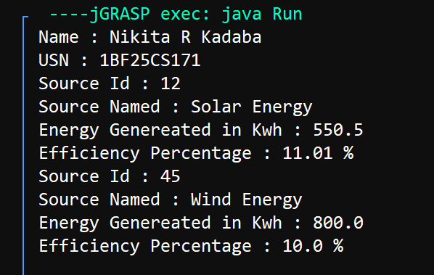

Question
b) Develop a Java program to create an interface ParkingCharge containing
the methods calculateCharge() and displayParkingDetails(). Create a class
VehicleParking with members Vehicle Number, Vehicle Type, and Parking
Hours. Derive the classes TwoWheeler and FourWheeler from
VehicleParking and implement the interface. Calculate the parking charge as
follows: For TwoWheeler, charge Rs. 20 per hour for the first two hours and
Rs. 10 per hour for each additional hour. For FourWheeler, charge Rs. 50 per
hour for the first two hours and Rs. 30 per hour for each additional hour.
Display vehicle details and total parking charge. Demonstrate runtime
polymorphism using a ParkingCharge reference.

Program :
interface Parkingcharge
{
void calculatecharge();
void displayDetails();
}
class VehicleParking
{
int vnum;
String vtype;
int hours;
VehicleParking(int v,String t,int h)
{
vnum=v;
vtype=t;
hours=h;
}
}
class TwoWheeler extends VehicleParking implements Parkingcharge
{
double c;
TwoWheeler(int v,String t,int h)
{
super(v,t,h);
c=0.0;
}
public void calculatecharge()
{
if(hours<=2)
c=hours*20;
else
c=40+((hours-2)*10);
}
public void displayDetails()
{
System.out.println("Vehicle Number : "+vnum);
System.out.println("Vehicle Type : "+vtype);
System.out.println("No of hours in Parking : "+hours);
System.out.println("Parking Charge : "+c);
}
}
class FourWheeler extends VehicleParking implements Parkingcharge
{
double c1;
FourWheeler(int v,String t,int h)
{
super(v,t,h);
c1=0.0;
}
public void calculatecharge()
{
if(hours<=2)
c1=hours*50;
else
c1=100+((hours-2)*30);
}
public void displayDetails()
{
System.out.println("Vehicle Number : "+vnum);
System.out.println("Vehicle Type : "+vtype);
System.out.println("No of hours in Parking : "+hours);
System.out.println("Parking Charge : "+c1);
}
}
class Run
{
public static void main(String args[])
{
System.out.println(“Name : Nikita R Kadaba\nUSN : 1BF25CS171”);
Parkingcharge v1=new TwoWheeler(1081,"Two Wheeler",5);
Parkingcharge v2=new FourWheeler(8001,"Four Wheeler",5);
v1.calculatecharge();
v1.displayDetails();
v2.calculatecharge();
v2.displayDetails();
}
}

Output:

